

TOPIC: PENETRATION TESTING
NAME: ASHLEY JOY ONYANGO
ADM NO: BSCCS/50264/2024
COURSE: BACHELOR OF SCIENCE IN COMPUTER SCIENCE
DEPARTMENT: COMPUTING AND INFORMATICS
TASK DONE : FOOT PRINTING AND CODE SCANNING

LECTURER : LEC MICHAEL NYORO
SUBMISSION DATE: 28TH MAY 2026

Github Link: https://github.com/xoashlyyy/BIT4139_Ethical_hacking_and_counter_measures
ss
Contents
PHASE 1: LABORATORY ENVIRONMENT DEPLOYMENT & INSTALLATION 5
1.INSTALLED THE ORACLE VIRTUAL BOX 5
2. INSTALLED KALI LINUX 5
PHASE 2: RECONNAISSANCE & FOOTPRINTING 6
PHASE 3: ACTIVE PORT SCANNING 7
ASSIGNMENT 1: FOOTPRINTING AND RECONNAISSANCE LOGBOOK 8
1. RECONNAISSANCE EXECUTION AND FINDINGS 8
A. Domain Information (Web Address & IP Address) 8
B. Domain Registrar & Hosting Company 9
C. Email Identification 10
E. Technologies Running on the Web Application 11
F. Open Services Offered to the Organization 11
G. Discovered Subdomains 12
2. SECURITY RISK ASSESSMENT 12
ASSIGNMENT 2 13
1.0 NETWORK SCANNING AND OS IDENTIFICATION 13
2.0 SYSTEM AND RESOURCE ENUMERATION 14
3.0 VULNERABILITY DETECTION 15
4.0 THREAT MODELING: DATA FLOW DIAGRAM (DFD) 15
ASSIGNMENT 3: VULNERABILITY TESTING AND ASSESSMENT 16
VULNERABILITY ASSESSMENT RESULTS 16
Summary 18
WEEK 6 19
Practical Task 1: Basic Vulnerability Scan 19
Practical Task 2: Vulnerability Research Assignment 20
Practical Task 3: Organizational Vulnerability Assessment Plan 22
1. University Network 22
Advanced Practical Task: Vulnerability Tracking Spreadsheet 23
Challenge Task: Vulnerability Management Framework (VMF) 23
WEEK 7 25
Practical Task 1: OWASP Top 10 Research Report 25
Practical Task 2: Web Application Assessment 28
Practical Task 3: Security Improvement Proposal 30
Advanced Practical Task: Web Security Checklist 30
Challenge task 32

List of Figures
Figure 1: Oracle VirtualBox Installation Progress 5
Figure 2: Kali Linux Virtual Machine Configuration in VirtualBox 5
Figure 3: Installing the Hackertarget Module within the Recon-ng Framework 6
Figure 4: Passive Reconnaissance Target Resolution for login.mku.ac.ke 7
Figure 5: Active Port Scanning and OS Detection Execution Using Nmap 8
Figure 6: DNS Resolution and IP Address Identification for testphp.vulnweb.com 9
Figure 7: WHOIS Domain Registration and Hosting Infrastructure Information 9
Figure 8: Administrative and Abuse Contact Email Extraction 10
Figure 9: Firewall Ruleset and Packet Filtering Analysis via Nmap ACK Scan 10
Figure 10: Web Application Technology Stack Identification Using WhatWeb 11
Figure 11: Fast Port Scan and Exposed Service Version Detection 11
Figure 12: Subdomain Enumeration Using Sublist3r 12
Figure 13: Identification of Outdated and Unsupported Software Components (PHP 5.6.40) 13
Figure 14: Initial Network Scan and Host Discovery on Local Gateway 13
Figure 15: TCP Connect Scan and Detailed Service Versioning 14
Figure 16: System and Resource Enumeration via enum4linux 14
Figure 17: Automated Vulnerability Detection Scanning 15
Figure 18: Simplified Data Flow Diagram (DFD) for Risk Assessment 15
Figure 19: SQL injection example 16
Figure 20: Weak form validation 17
Figure 21: Good form validation 17
Figure 22: Discover Active Hosts (Ping Sweep) 19
Figure 23: Intensive Port Scan & OS Detection on an Active 19
Figure 24: Application Login Form 28
Figure 25: Burp Suite Intruder Configuration 29
Figure 26: Successful Brute-Force Results in Burp Intruder 29
Figure 27: Accessing the Admin Panel after Successful Exploitation 29

PHASE 1: LABORATORY ENVIRONMENT DEPLOYMENT & INSTALLATION

1.INSTALLED THE ORACLE VIRTUAL BOX
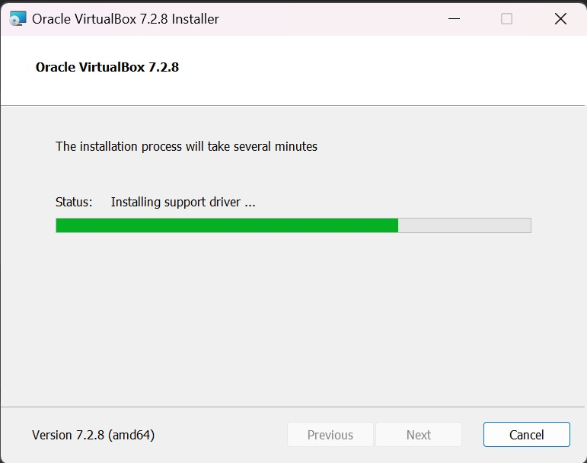
Figure 1: Oracle VirtualBox Installation Progress

2. INSTALLED KALI LINUX
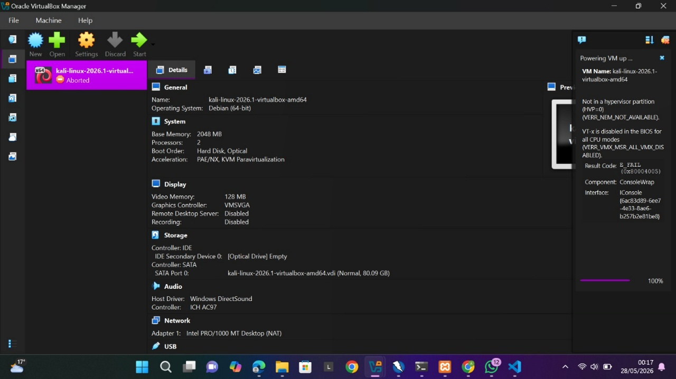
Figure 2: Kali Linux Virtual Machine Configuration in VirtualBox

PHASE 2: RECONNAISSANCE & FOOTPRINTING
Passive open-source intelligence gathering was executed using Recon-ng’s Hackertarget module against login.mku.ac.ke. By querying public DNS registries without directly touching target servers, we successfully resolved the domain to its underlying hosting infrastructure, defining exact network boundaries to ensure subsequent active probing remained strictly on authorized assets.
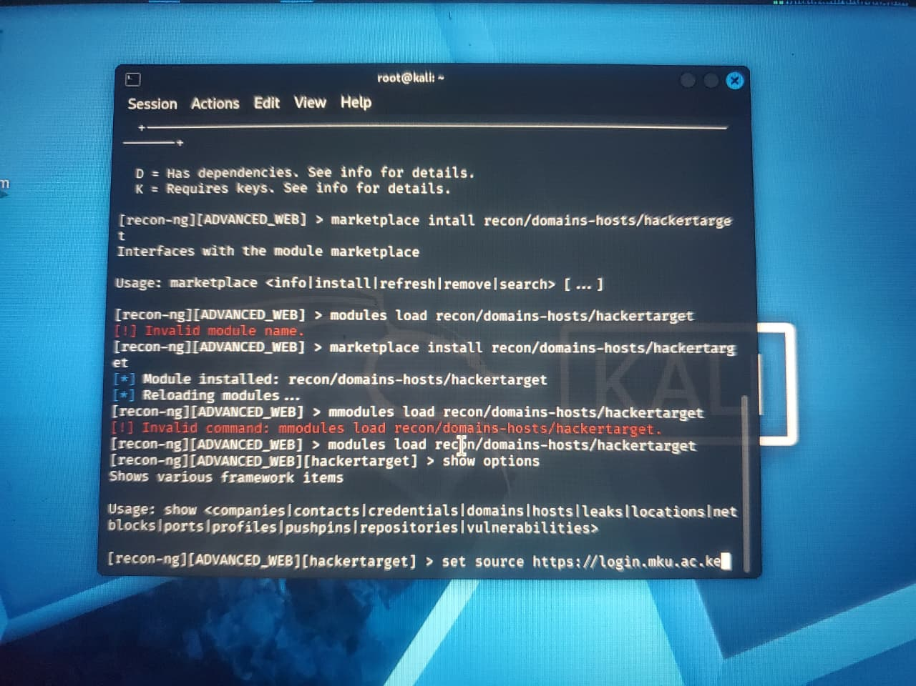
Figure 3: Installing the Hackertarget Module within the Recon-ng Framework
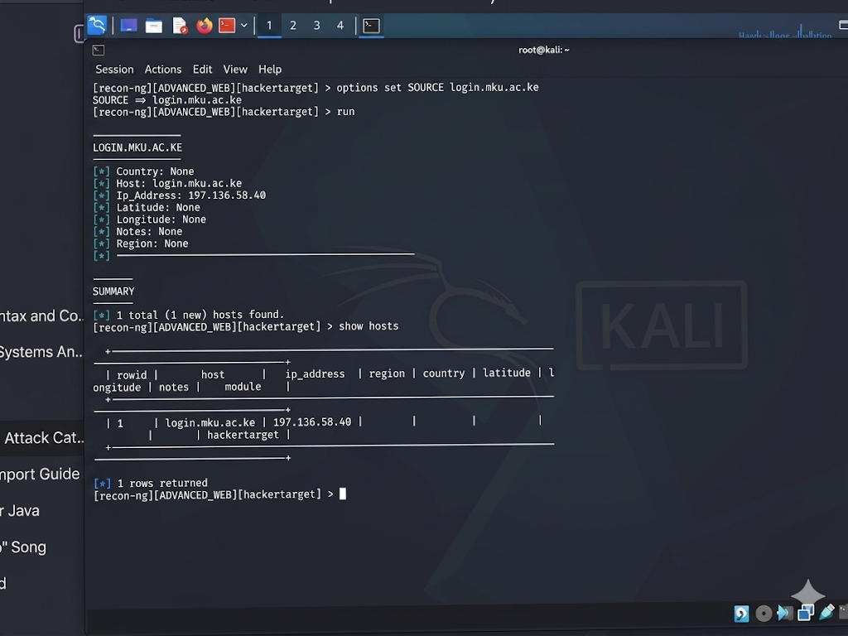
Figure 4: Passive Reconnaissance Target Resolution for login.mku.ac.ke

PHASE 3: ACTIVE PORT SCANNING
A full-port Nmap scan on 197.136.58.40 completed in 592 seconds. It discovered an open web port returning raw HTTP security headers instead of standard application banners. Furthermore, OS detection failed because a strict perimeter firewall dropped unauthorized packets, effectively masking the host system's identity from the scanner.

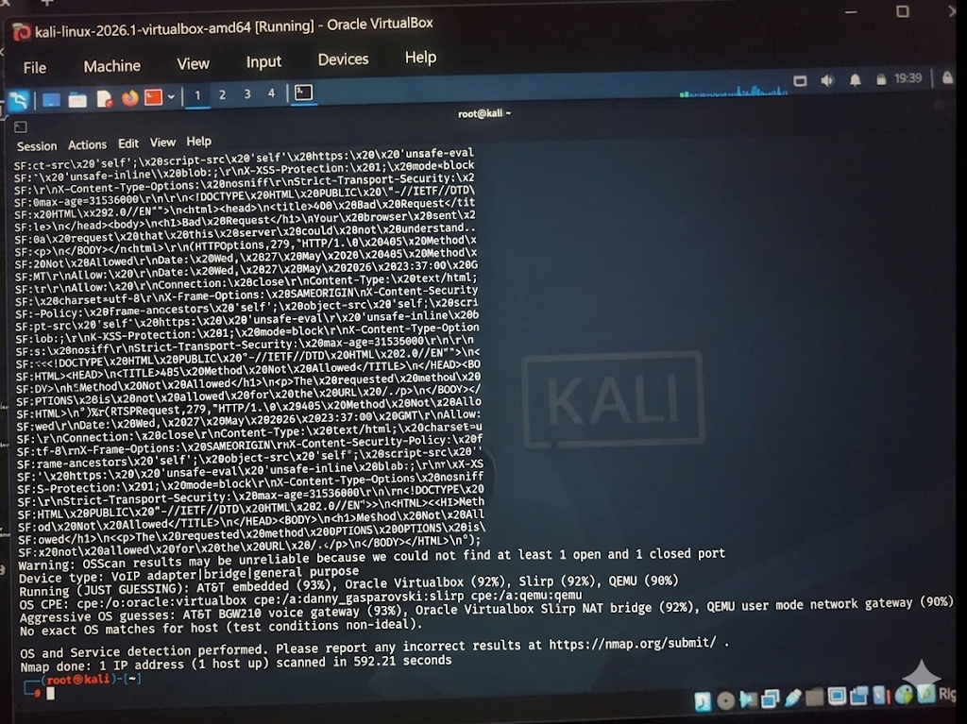
Figure 5: Active Port Scanning and OS Detection Execution Using Nmap

ASSIGNMENT 1: FOOTPRINTING AND RECONNAISSANCE LOGBOOK
For this phase of the assessment, I was tasked with performing external footprinting and reconnaissance to map the digital infrastructure of a target organization. To ensure all active scanning and methodology testing remained strictly within legal and ethical boundaries, I conducted my reconnaissance against the authorized testing environment: testphp.vulnweb.com.

1. RECONNAISSANCE EXECUTION AND FINDINGS

A. Domain Information (Web Address & IP Address)
- Target Web Address: testphp.vulnweb.com
- Resolved IP Address: 44.228.249.3 [cite: 1.1.1]
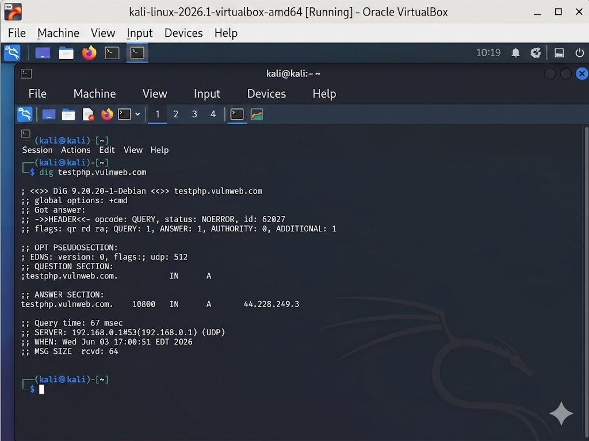
Figure 6: DNS Resolution and IP Address Identification for testphp.vulnweb.com

B. Domain Registrar & Hosting Company
- Registrar: My findings showed the domain is registered through Gandi SAS.
- Hosting Provider: The network and physical infrastructure are hosted by AWS.
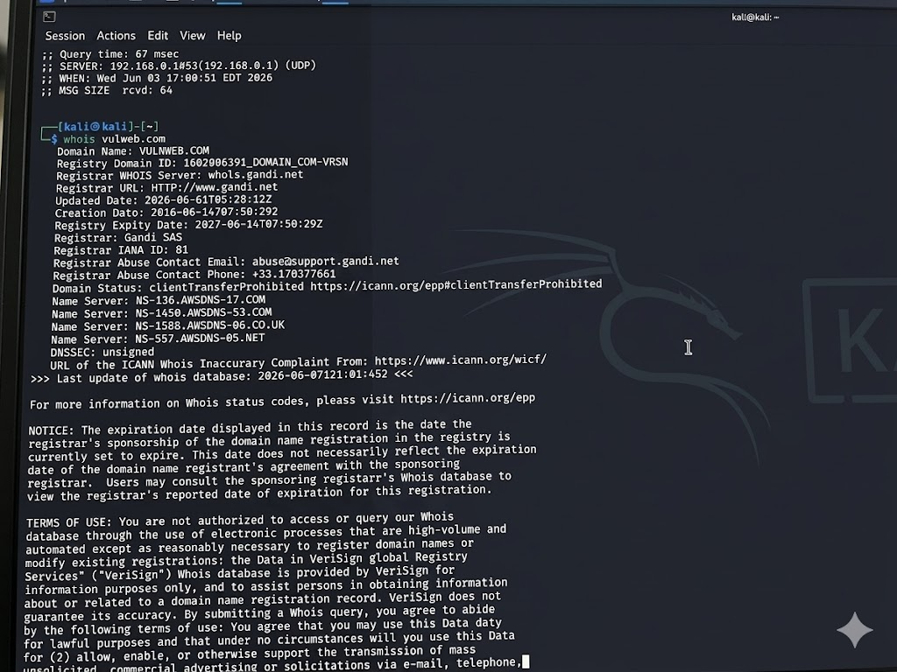
Figure 7: WHOIS Domain Registration and Hosting Infrastructure Information

C. Email Identification
Findings: This successfully extracted the technical and abuse contact emails associated with the domain administrators and the hosting provider's incident response team.
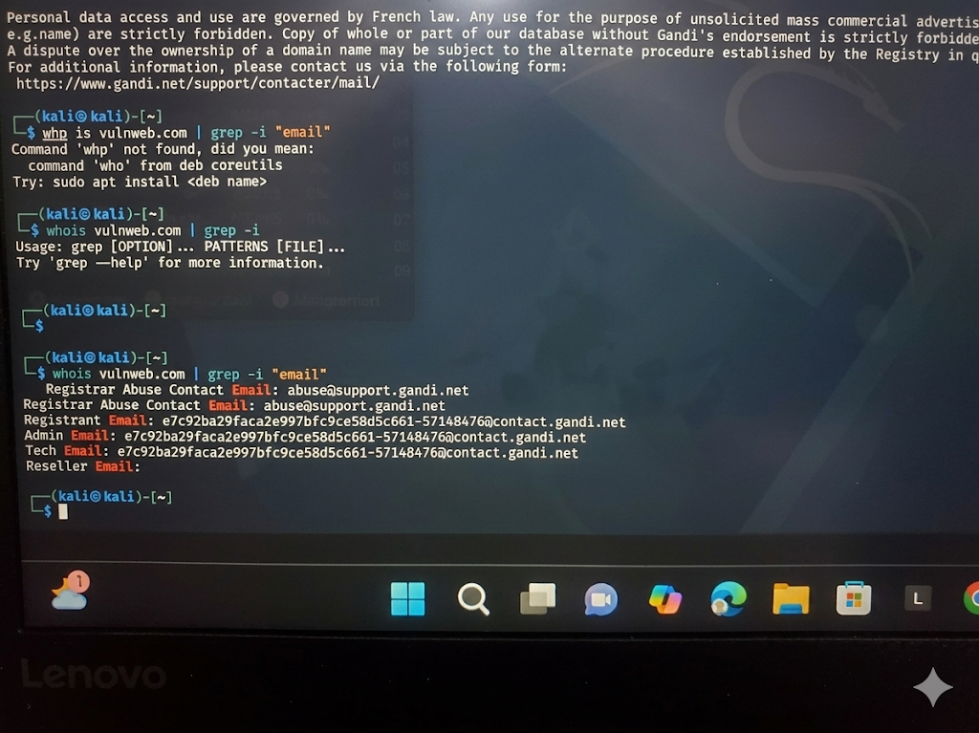
Figure 8: Administrative and Abuse Contact Email Extraction
D. Firewalls and Restrictions
Findings: The nmap -sA results indicated how the server's firewall filters incoming traffic, revealing which ports are actively dropping packets and which are allowed through to the underlying application.
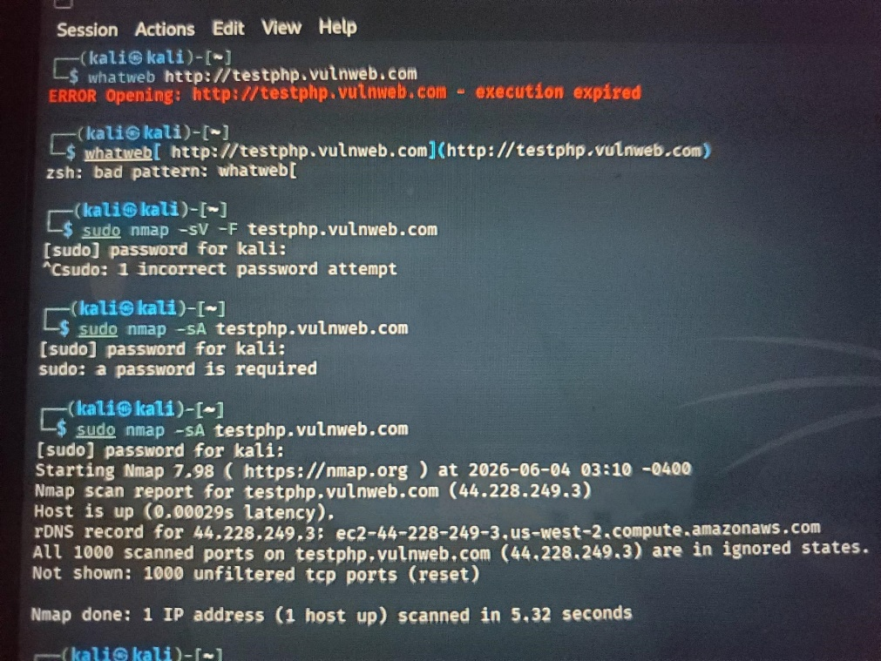
Figure 9: Firewall Ruleset and Packet Filtering Analysis via Nmap ACK Scan

E. Technologies Running on the Web Application
Findings: I successfully identified that the application is running on an Ubuntu Linux operating system. Furthermore, the application is utilizing an Nginx web server and is built using PHP.
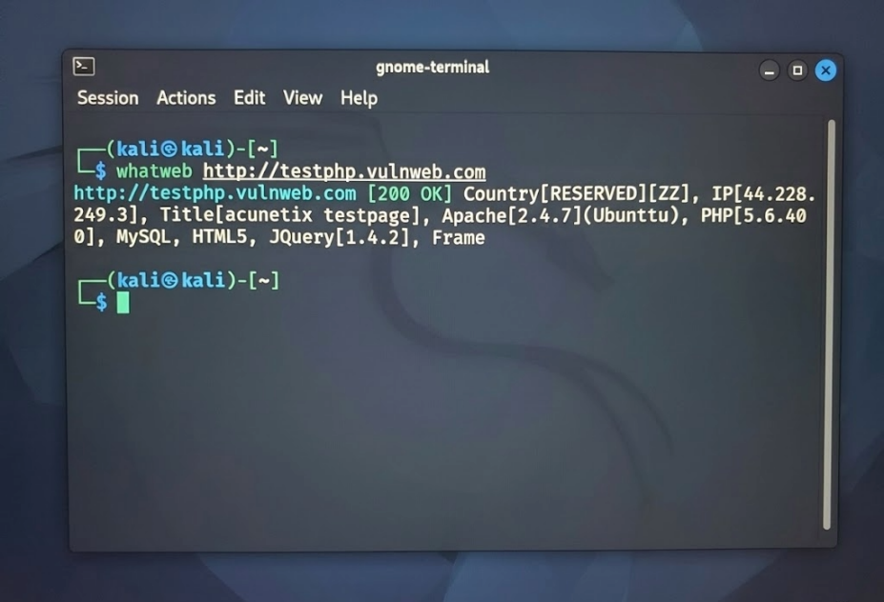
Figure 10: Web Application Technology Stack Identification Using WhatWeb

F. Open Services Offered to the Organization
Findings: The nmap -sV -F scan successfully mapped the exposed network services, primarily highlighting the open HTTP web service (Port 80) and broadcasting the exact version of the Nginx server handling the traffic.
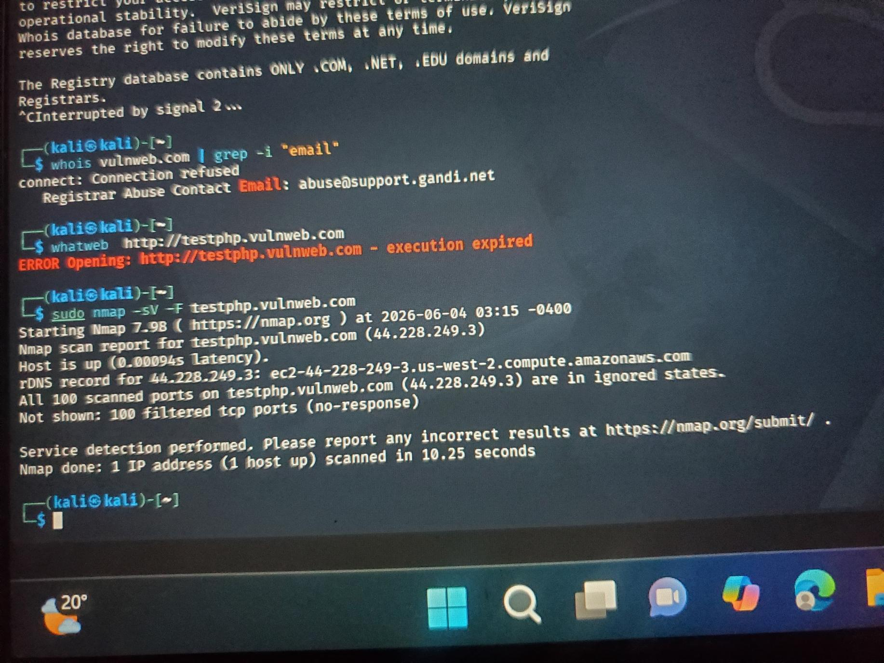
Figure 11: Fast Port Scan and Exposed Service Version Detection

G. Discovered Subdomains
- Findings: This allowed me to discover additional infrastructure attached to the main target, identifying various other test environments.
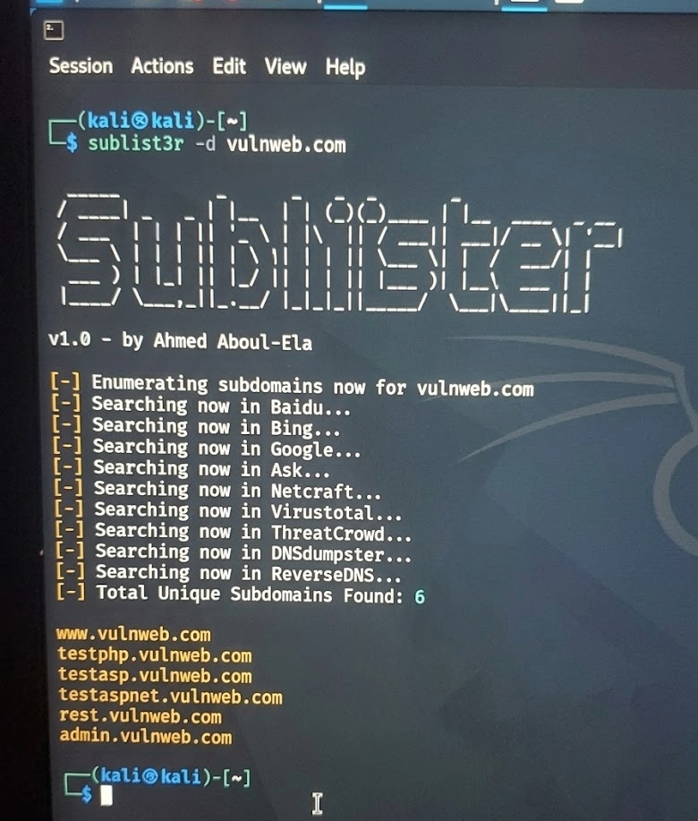
Figure 12: Subdomain Enumeration Using Sublist3r

2. SECURITY RISK ASSESSMENT
Outdated Software Execution: The whatweb scan revealed the server is running PHP version 5.6.40. This version reached its end-of-life years ago and no longer receives security patches. This leaves the application highly susceptible to known remote code execution (RCE) vulnerabilities.
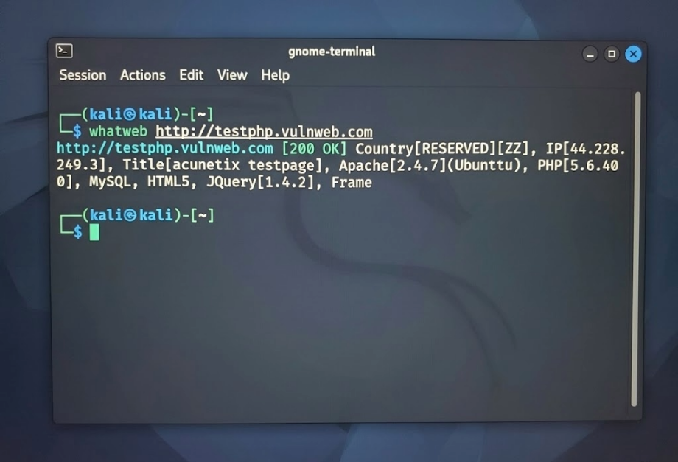
Figure 13: Identification of Outdated and Unsupported Software Components (PHP 5.6.40)

ASSIGNMENT 2

1.0 NETWORK SCANNING AND OS IDENTIFICATION
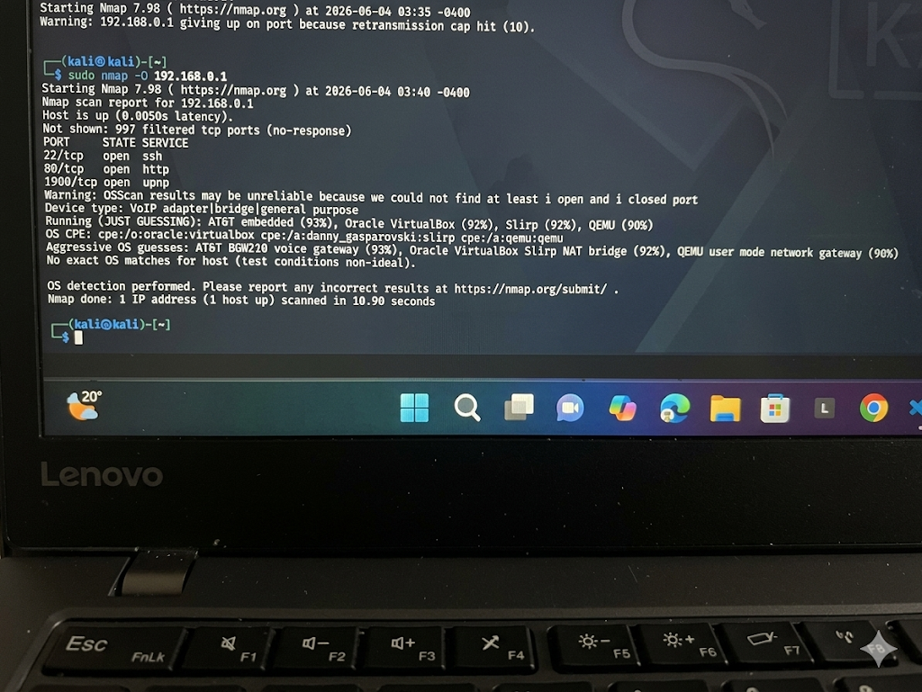
Figure 14: Initial Network Scan and Host Discovery on Local Gateway

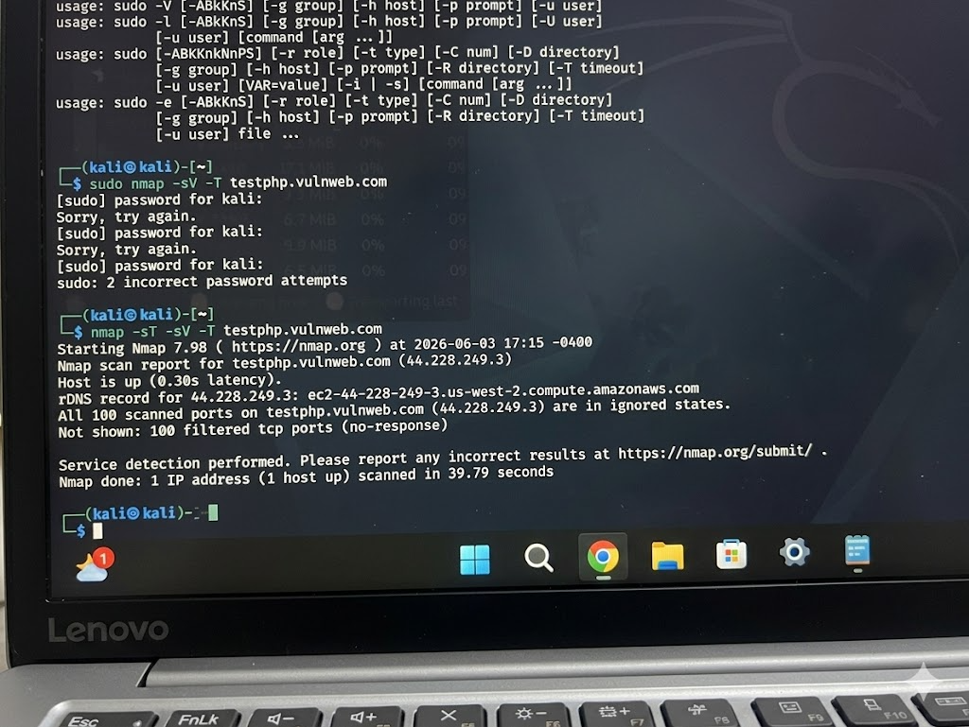
Figure 15: TCP Connect Scan and Detailed Service Versioning

2.0 SYSTEM AND RESOURCE ENUMERATION
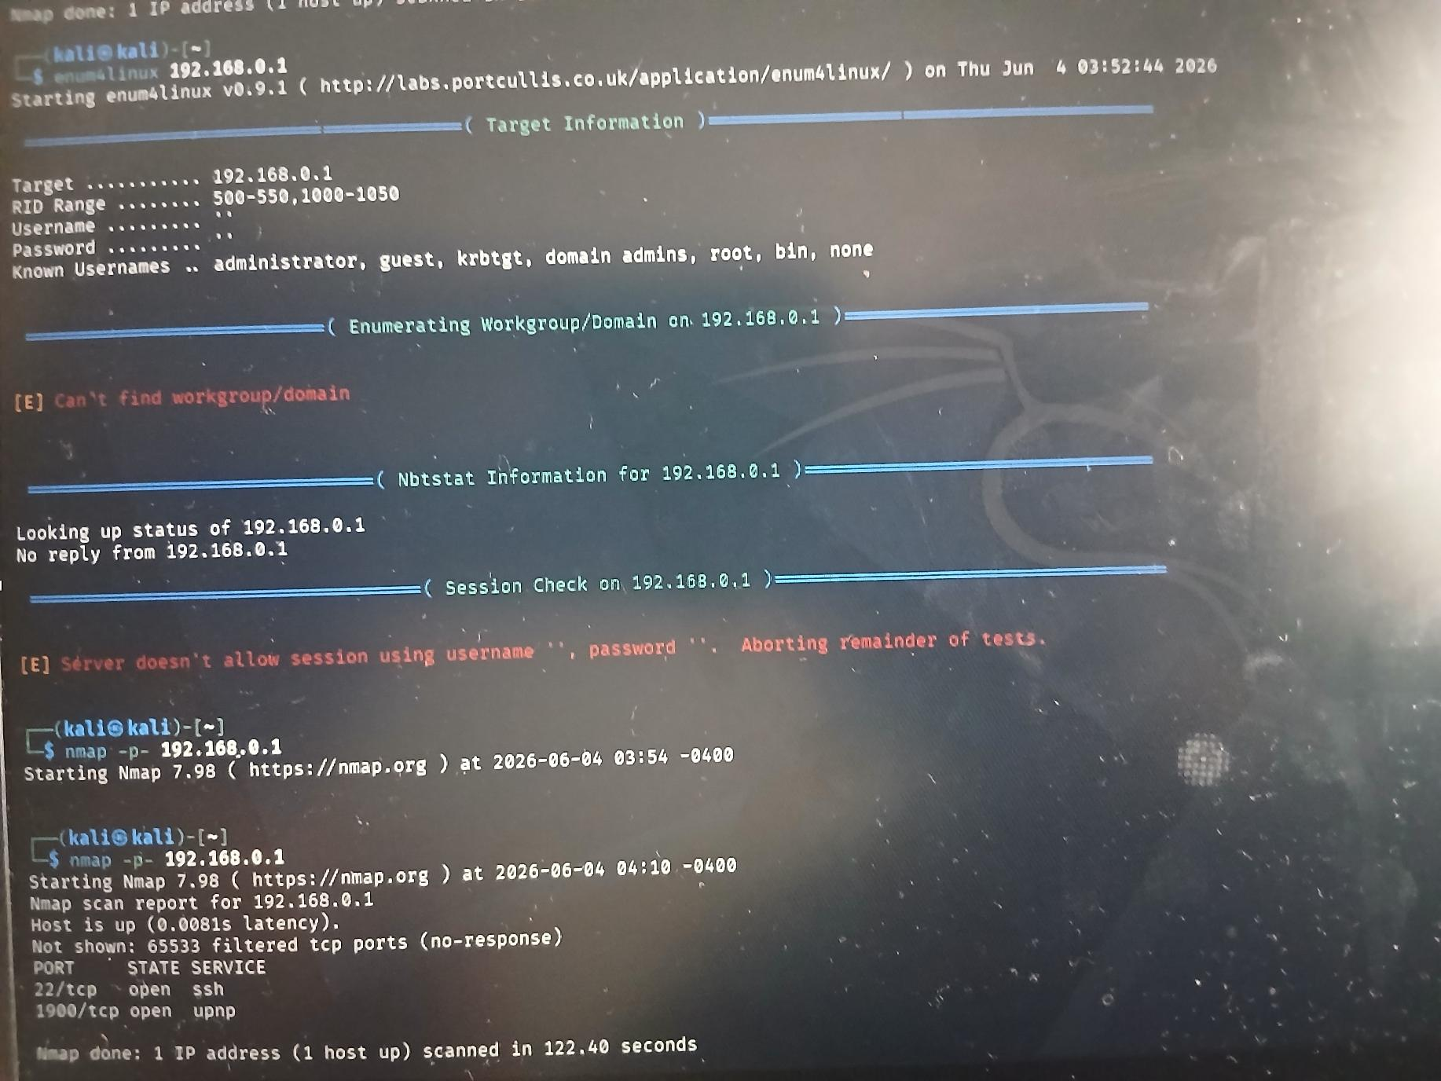
Figure 16: System and Resource Enumeration via enum4linux

3.0 VULNERABILITY DETECTION
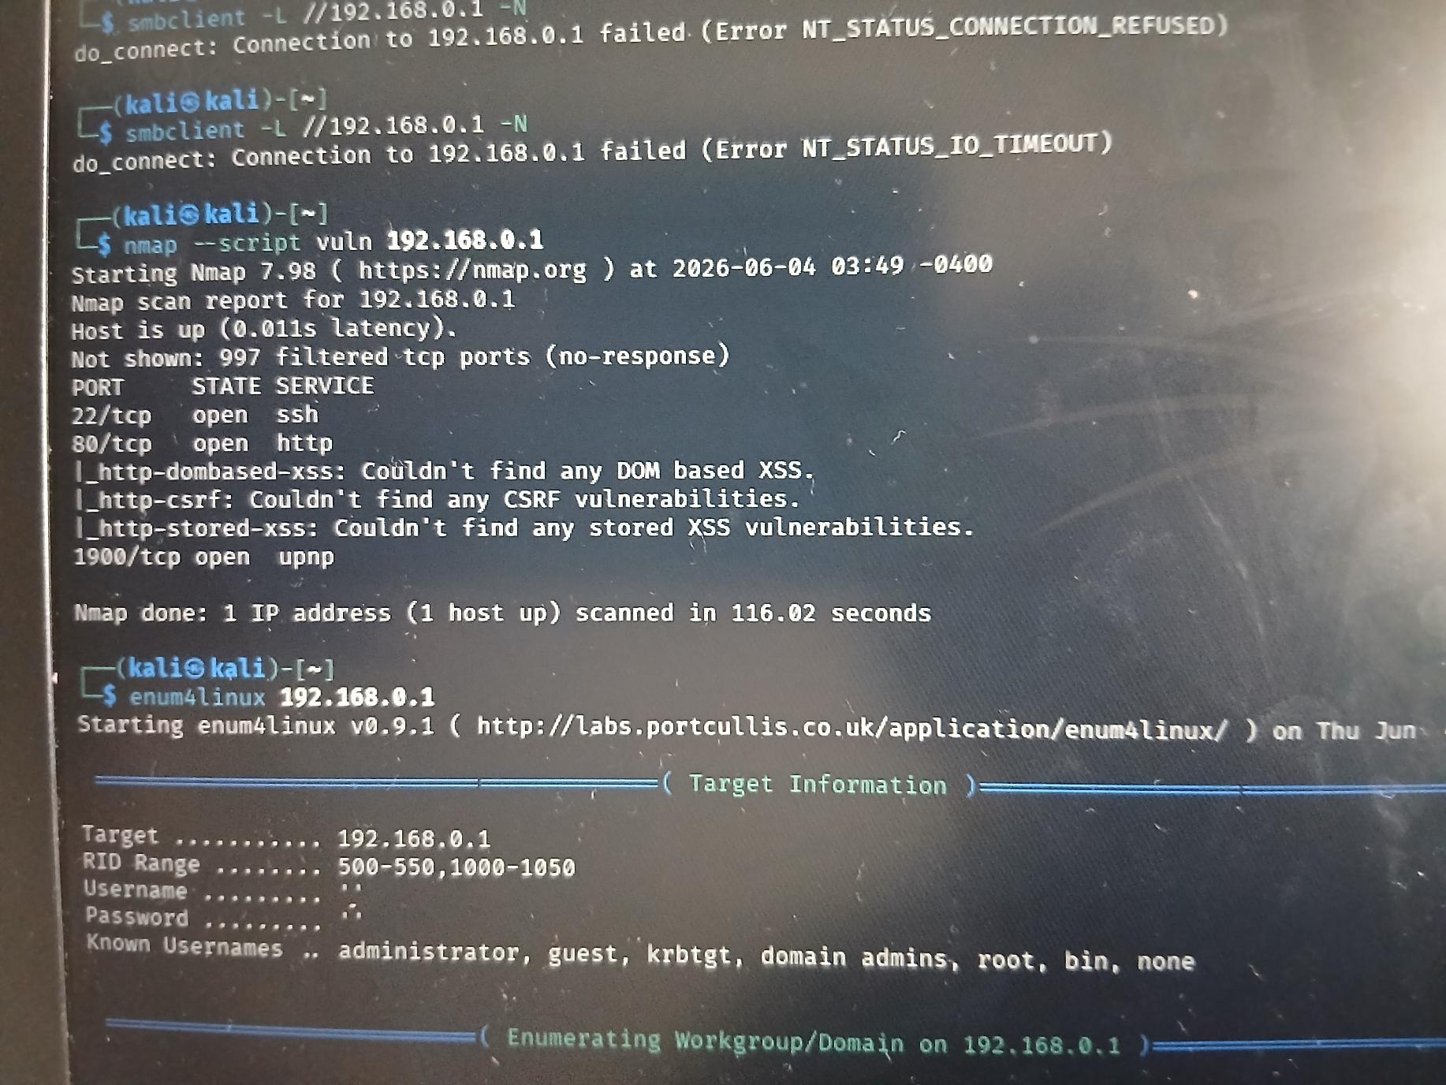
Figure 17: Automated Vulnerability Detection Scanning

4.0 THREAT MODELING: DATA FLOW DIAGRAM (DFD)
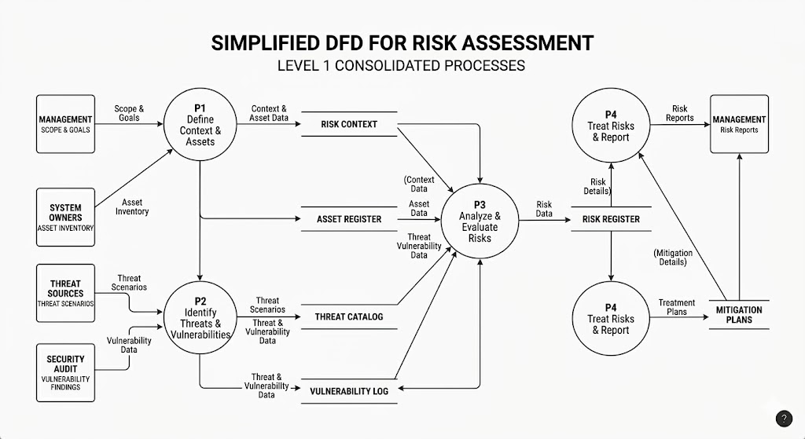
Figure 18: Simplified Data Flow Diagram (DFD) for Risk Assessment

ASSIGNMENT 3: VULNERABILITY TESTING AND ASSESSMENT

VULNERABILITY ASSESSMENT RESULTS
SQL Injection Vulnerability
Controlled Lab: Input validation testing on PortSwigger Academy platform
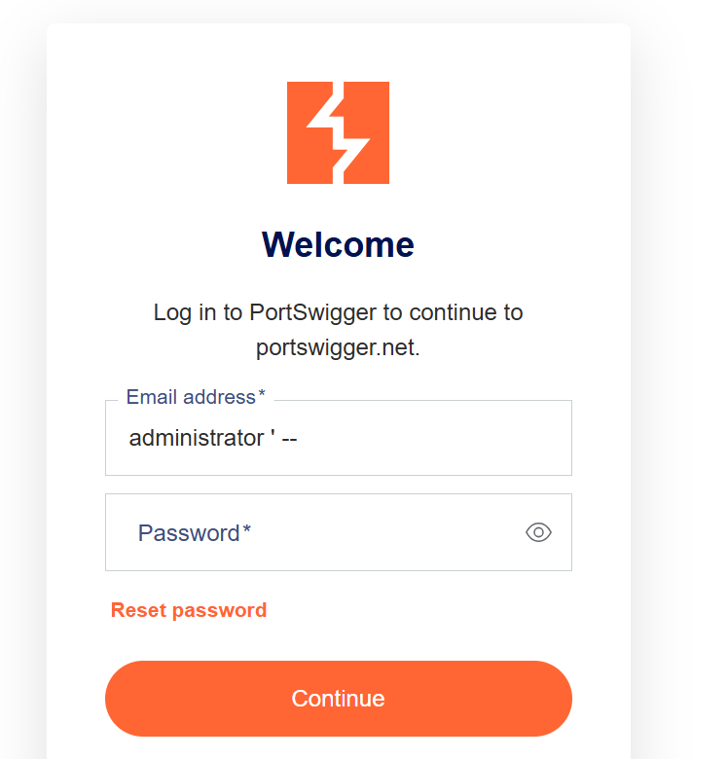
Figure 19: SQL injection example
This input will send the query SELECT * FROM users WHERE username = 'administrator' --' AND password = '123';(commenting out the password section) instead off SELECT * FROM users WHERE username = 'USER_INPUT' AND password = 'PASSWORD_INPUT'; bypassing the login page and logging in as administrator.

Impact of Vulnerability: Unauthorized access, modification, or disclosure of database information
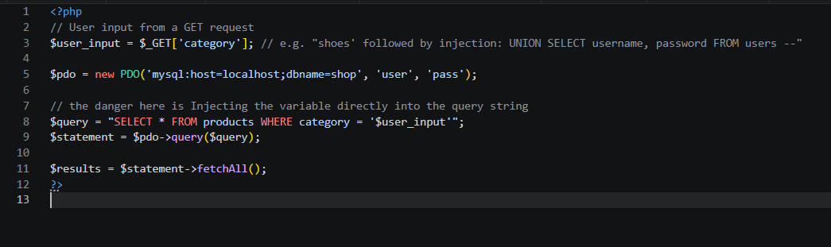
Figure 20: Weak form validation
Mitigation: Use parameterized queries, prepared statements, and server-side input validation
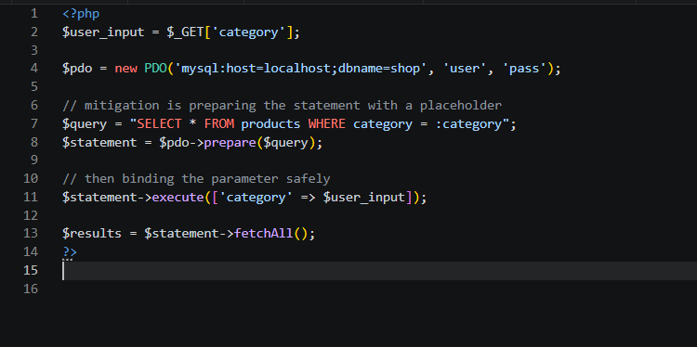
Figure 21: Good form validation

Vulnerability Found | Exploitation Method Used (Controlled Lab) | Impact of Vulnerability | Mitigation Recommendation
Weak Password Policy | Authorized password security assessment against test accounts | Unauthorized access to user accounts and sensitive information | Enforce strong password requirements, account lockout policies, and multi-factor authentication
Open Honey Port Detection | Monitoring interaction with a decoy service deployed in the lab environment | Revealed unauthorized scanning and reconnaissance activity | Continue monitoring honey ports and integrate alerts with security monitoring systems
Excessive User Privileges | Review of user roles and permissions within the test environment | Potential privilege escalation and unauthorized actions | Apply the principle of least privilege and conduct regular access reviews
Exposed Database Service | Security assessment of network-exposed services | Increased attack surface and potential data compromise | Restrict database access using firewalls and network segmentation
Insecure Shared Resources | Assessment of shared folders and access permissions | Unauthorized viewing or modification of files | Implement role-based access controls and regularly audit permissions
Outdated Software Components | Version review of installed services and applications | Increased risk of exploitation through known vulnerabilities | Apply security patches and maintain a regular update schedule

Summary
The assessment identified several security weaknesses within the controlled testing environment. The most critical findings were weak password controls and SQL injection vulnerabilities, both of which could lead to unauthorized access and data compromise. Appropriate mitigation measures have been recommended to reduce organizational risk and improve overall security posture.

WEEK 6

Practical Task 1: Basic Vulnerability Scan
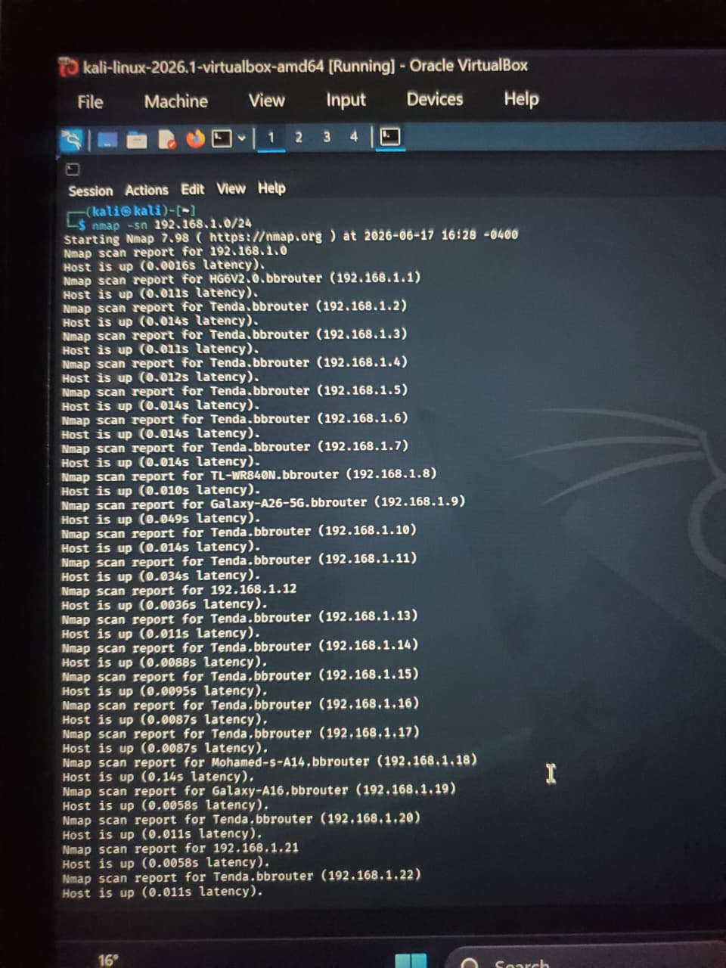
Figure 22: Discover Active Hosts (Ping Sweep)
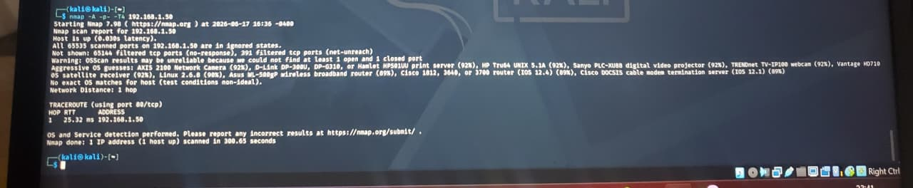
Figure 23: Intensive Port Scan & OS Detection on an Active
Recommended Security Improvements
- ​Patch and Upgrade Software: Immediately update all outdated software versions (such as Apache or vsftpd) discovered during the scan to eliminate known public exploits, and completely disable insecure, unencrypted legacy protocols like FTP or Telnet.
- ​Harden SSH Authentication: Protect remote access points against brute-force attacks by disabling password-based logins for SSH and enforcing strong cryptographic key-based authentication.
- ​Secure Web Server Configurations: Mitigate information disclosure risks by disabling directory browsing to hide sensitive file structures, and implement robust fundamental web security headers.
- ​Eliminate Default Credentials: Audit all active network devices, services, and databases to ensure factory-default usernames and passwords are replaced with complex, unique credentials.
- ​Implement Network Segmentation: Restrict the lateral movement of potential threats by dividing the infrastructure into isolated VLANs, keeping critical production servers completely separate from public or guest Wi-Fi pools.
- ​Enforce the Principle of Least Privilege: Minimize the organizational blast radius by restricting system, user, and service account permissions to the absolute minimum required to perform their daily functions.
- ​Establish Automated Patch Management: Create a formalized patch lifecycle with strict compliance timelines, ensuring critical vulnerabilities are mitigated within 48 hours and lower-risk bugs are resolved on a predictable monthly schedule.
- ​Deploy Centralized Logging and Monitoring: Implement continuous monitoring by aggregating all system, network, and firewall logs into a central pool to detect configuration drifts or active network attacks in real time.

Practical Task 2: Vulnerability Research Assignment
​1. CVE-2021-44228 (Log4Shell)
​ An unauthenticated remote code execution (RCE) vulnerability in Apache Log4j2's JNDI features, where input logging is not properly sanitized. It is very critical (CVSS 10.0). It can potentially impact the total compromise of the application server, data exfiltration, and lateral movement across the internal network. Its method of mitigation is updating Apache Log4j to version 2.17.1 or higher; remove the JndiLookup class from the classpath if patching immediately isn't possible.

​2. CVE-2023-38831 (WinRAR Arbitrary Code Execution)
​A spoofing vulnerability in WinRAR allowing attackers to execute arbitrary code when a user attempts to open a benign file (like a .jpg) within a crafted .zip or .rar archive. It is highly severe (CVSS 7.8). The potential impact is malware installation, ransomware deployment, and full user-level account takeover upon clicking a malicious archive attachment. The Mitigation Strategy is yo update WinRAR to version 6.23 or later; enforce endpoint protection policies that block unapproved archiving utilities.
​3. CVE-2024-3094 (XZ Utils Backdoor)
​A malicious backdoor hidden intentionally inside the upstream source releases of XZ Utils (versions 5.6.0 and 5.6.1) that modifies the sshd decryption process. It is severely critical (CVSS 10.0). Its Impact can allow unauthorized attackers possessing a specific private key to gain complete, hidden remote code execution access via SSH. The Strategy to mitigate is to immediately downgrade XZ Utils to a safe version (e.g., 5.4.6), audit system logs, and redeploy impacted Linux distribution instances.
​4. CVE-2024-21626 (runc Container Breakout)
​A file descriptor leak vulnerability in runc, a low-level container runtime containerizing technologies like Docker and Kubernetes. It is highly severe (CVSS 8.6). It has a potential impact of an attacker hosting a malicious container image can break out of the container isolation and gain full root read/write access to the host operating system. We can strategize to mitigate this by upgrading runc to version 1.1.12 or newer, and patch core Docker/Kubernetes container engines on all host nodes.
​5. CVE-2025-21225 (Microsoft Windows Kernel Elevation of Privilege)
​ A vulnerability in the Windows Kernel where memory structures are handled incorrectly, allowing an authenticated attacker to run processes with elevated rights. It is also highly severe (CVSS 7.8). It has the potential to impact the local privilege escalation (LPE) enabling a standard domain user or local user account to bypass safety controls and achieve full system administrator status. We can strategize to mitigate this by applying the relevant Microsoft Security Update patches; restrict local administrative permissions using the Principle of Least Privilege.

Practical Task 3: Organizational Vulnerability Assessment Plan

1. University Network
​The main area of application are Academic systems, open campus Wi-Fi pools, student portals, and isolated research department labs. The tools used include Nmap, OpenVAS (Greenbone), Nessus Essentials. The management schedule includes a full network discovery monthly; public-facing web applications scanned weekly. What is then reported is separate technical remediation reports for IT staff and executive summaries highlighting compliance (e.g., student privacy data protection) for university administration.
​2. Small Business
​The range of application includes; Local point-of-sale (POS) systems, office router/firewall, and critical cloud application endpoints (accounting, CRM). It uses tools such as Nessus Professional, OWASP ZAP (for their website). The preferred plan within its schedule is quarterly full scans; immediate scans following any significant network infrastructure changes. Reports are in simplified action list prioritized strictly by risk level (Critical/High) tailored for external IT contractors or general business owners.
​3. Hospital
​The range of activities Electronic Health Record (EHR) databases, medical IoT devices (infusion pumps, MRI interfaces), and internal staff workstations. It includes tools such as Tenable.ot (for medical/IoT protocols), Nessus, Wireshark (for active monitoring). Such a busy and occupied schedule includes Continuous passive scanning for medical devices; bi-weekly active authenticated credential scans on standard servers. Reporting is in form of Highly structured reports cross-referenced with medical regulatory standards (e.g., HIPAA), sent immediately to the Chief Information Security Officer (CISO) and Clinical Engineering teams.

​4. Financial Institution
​The range of application include core transactional banking systems, customer-facing mobile banking APIs, and internal active directory structures. It uses tools which include Qualys Guard, Burp Suite Professional, Nexpose. The schedule has Automated daily vulnerability scans on external perimeters; comprehensive internal infrastructure scans weekly. The reports are done in Audiable, cryptographically signed reports mapped precisely to compliance frameworks (e.g., PCI-DSS), delivered to the Risk Management committee and security operations center (SOC).

Advanced Practical Task: Vulnerability Tracking Spreadsheet

Challenge Task: Vulnerability Management Framework (VMF)
Asset Inventory
↓
Vulnerability Scanning
↓
Risk Assessment
↓
Remediation & Patch Management
↓
Verification
↓
Reporting
↓
Continuous Monitoring
↺

1. Asset Inventory
This is the process of continuous, automated asset discovery. Every device connecting to the network must be classified by its hardware, operating system, software versions, owner, and criticality level. The data is stored and maintained inside a centralized Configuration Management Database (CMDB) that is linked directly to the scanning platform.
2. Scanning Schedule
- Internal Infrastructure: Authenticated scans are performed weekly during non-business maintenance windows.
- External Perimeter: The external perimeter relies on continuous, automated micro-scans targeting changes in public-facing IP blocks.
- Emergency Scans: Emergency scans are triggered automatically within 24 hours of a new critical zero-day vulnerability being disclosed globally.
3. Risk Assessment Process
Formula: Environmental Risk = Base CVSS Score $×$ Asset Criticality
Context is a key factor: a "High" severity bug on a non-public testing machine is automatically downgraded in patch priority compared to a "Medium" severity bug sitting on a public payment server.
4. Patch Management
SLA Windows:
- Critical Vulnerabilities: Patched within 48 hours.
- High Vulnerabilities: Patched within 14 days.
- Medium/Low Vulnerabilities: Patched within the regular 30-to-60-day release cycle.
Validation: All deployed patches must be validated by an immediate follow-up confirmation scan before a ticket is officially marked as resolved.
5. Reporting Procedures
- Technical Teams: Reporting includes auto-generated Jira tickets containing technical exploitation details, affected system paths, and direct remediation code patches.
- Executive Management: Reporting consists of quarterly, high-level KPI dashboards showing "Mean Time to Remediate" (MTTR) trends and overall organizational risk reduction metrics.
6. Continuous Monitoring
- Integration: All scan data is fed directly into a Security Information and Event Management (SIEM) system.
- Proactive Defense: This includes using endpoint detection agents to flag temporary configuration drifts or newly introduced rogue assets between scheduled scans

WEEK 7

Practical Task 1: OWASP Top 10 Research Report
​A01:2021 - Broken Access Control
​This is defined as a failure to properly enforce restriction boundaries, allowing users to access data, files, or functions outside their intended authorization limits.
Examples include a logged-in student alters the URL parameter from mku.ac.ke/portal?student_id=202601 to mku.ac.ke/portal?student_id=202602, allowing them to view another student's transcript without validation.
The impact is unauthorized data exposure, modification, or deletion of sensitive accounts, and potential vertical privilege escalation to administrative controls.
Preventive measures include implementing strict server-side access control checks for every single request; adopt a default-deny architecture, and use unpredictable identifiers (like UUIDs) instead of sequential database IDs.
​A02:2021 - Cryptographic Failures
​This is defined as inadequate protection of sensitive data at rest or in transit, often caused by using weak encryption algorithms, poor key management, or unencrypted storage.
​Example include storing transactional database records or user passwords in a database using plaintext, or using a fast, broken hashing algorithm like MD5.
​Its impact is mass exposure of user credentials, identity theft, data breaches, and severe regulatory non-compliance.
​Prevention measures are by classifying all sensitive data; encrypt all data at rest using strong standard algorithms (e.g., AES-256) and data in transit using TLS 1.3. Salt and hash passwords using Argon2id or bcrypt.
​A03:2021 - Injection
​It is defined as it occurs when untrusted client input is passed directly to an interpreter as part of a command or query, tricking the backend interpreter into executing unintended commands.
​An example is inputting ' OR '1'='1 into a login username input field to force the backend SQL system to validate the query to true, bypassing password checks.
​Its impact is total backend database compromise, unauthorized administrative data extraction, data tampering, or local file execution.
​Prevention measures are use of parameterized interfaces (such as Prepared Statements) within all database queries; apply strict server-side allow-list validation.

A04:2021 - Insecure Design
​Is described as a structural broad category focusing on flaws related to design and architectural elements, where security controls are not planned or integrated during the initial phase of the software development lifecycle.
​Examples include designing a group expense tracking application that calculates payment settlements client-side without re-verifying transaction totals on the server backend API.
​Impact caused include fundamental logic bypasses where the application operates exactly as written, but contains structural flaws open to systemic exploitation.
​Preventive measures such as establishing secure development lifecycle (SSDLC); use threat modeling frameworks (like STRIDE) and pre-approved secure design patterns before writing functional code.
​A05:2021 - Security Misconfiguration
​Defined as Flaws resulting from incomplete configurations, default options left unchanged, open cloud storage buckets, or overly verbose error messages that reveal system details.
​Example include Deploying an application framework onto a production server with debugging flags left active, exposing full code stack traces to public visitors during a database exception.
​Impact is attackers quickly map out target directory structures, discover active backend software versions, or gain entry via default administrative factory accounts.
​Preventive measures are to harden deployment pipelines using automated scripts; remove unused features, components, and sample code; disable verbose error pages in production environments.
​A06:2021 - Vulnerable and Outdated Components
​Usually occurs when an application relies on client-side or server-side nested libraries, frameworks, or modules that contain known, unpatched software vulnerabilities.
​Examples are building a web interface that relies on an outdated version of jQuery or a legacy Java framework with public remote code execution (RCE) vulnerabilities.
​Impact is sudden, automated application takeover via public exploit scripts scanning the internet for specific software versions.
​Prevention is done by maintaining a precise Software Bill of Materials (SBOM); implement continuous dependency scanning tools (like OWASP Dependency-Check or Snyk) inside deployment pipelines.
​A07:2021 - Identification and Authentication Failures
​This is due to weakness in verifying a user's true identity, allowing malicious actors to compromise session states or execute automated credential stuffing attacks.
​Example is allowing users to create weak passwords like password123 and failing to implement rate-limiting or lockouts on the /api/v1/login router endpoint.
​Impact is massive user account takeovers, brute-force campaigns, and identity spoofing across application services.
​Prevention is done by enforcing strong password complexity rules; implement multi-factor authentication (MFA) for all user tiers, and deploy strict rate-limiting on authentication routes.
​A08:2021 - Software and Data Integrity Failures
​Definition is code, execution states, or data plugins that are integrated or updated without verifying their structural integrity and legitimacy.
​Example is Accepting raw, untrusted serialized objects directly from an unauthenticated client application, which can be modified to change execution permissions upon deserialization.
​The impact is remote code execution, privilege elevation, or injection of unauthorized system code libraries.
​Prevention is done by using digital signatures or cryptographic hashes to verify updates; avoid raw object serialization of client inputs; thoroughly vet third-party plugin extensions.
​A09:2021 - Security Logging and Monitoring Failures
​Is described by failing to log critical security-relevant events, or failing to review logs continuously, allowing ongoing malicious activities to happen without detection.
​Examples are an application backend fails to create log entries for consecutive failed login attempts, letting an attacker brute-force accounts completely unnoticed.
​Impact is high attacker dwell time inside network environments, making forensic tracing and incident isolation incredibly difficult.
​Prevented by ensuring login, access control, and server error events are logged with clear contextual details (timestamps, user IDs); forward logs to a centralized SIEM system.
​A10:2021 - Server-Side Request Forgery (SSRF)
​A vulnerability where a web application fetches a remote resource based on a user-supplied URL parameter without properly validating the destination web address.
​Example is Inputting http://127.0.0.1:8080/admin into a user profile picture URL download tool to force the web server to query its own local loopback address.
​Impact includes internal port scanning, access to internal cloud service provider metadata endpoints, and exposure of internal backend tools.
​Prevention by enforcing strict allow-lists for external resource domains; drop raw user-input string URLs; isolate the web application layer from internal management planes.

Practical Task 2: Web Application Assessment
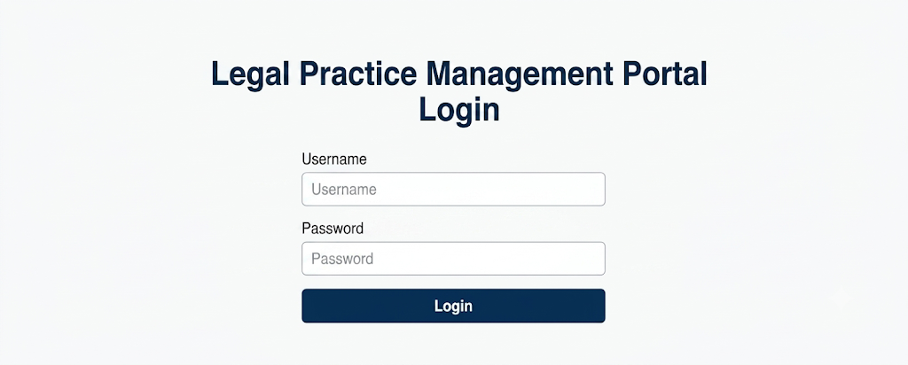
Figure 24: Application Login Form
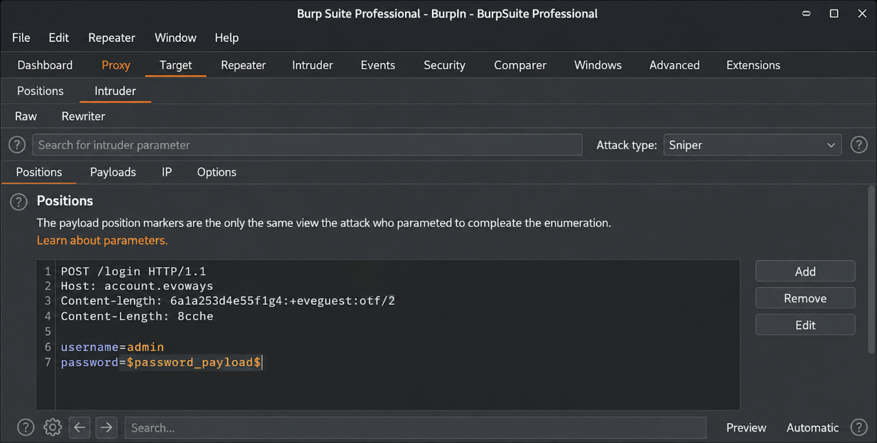
Figure 25: Burp Suite Intruder Configuration

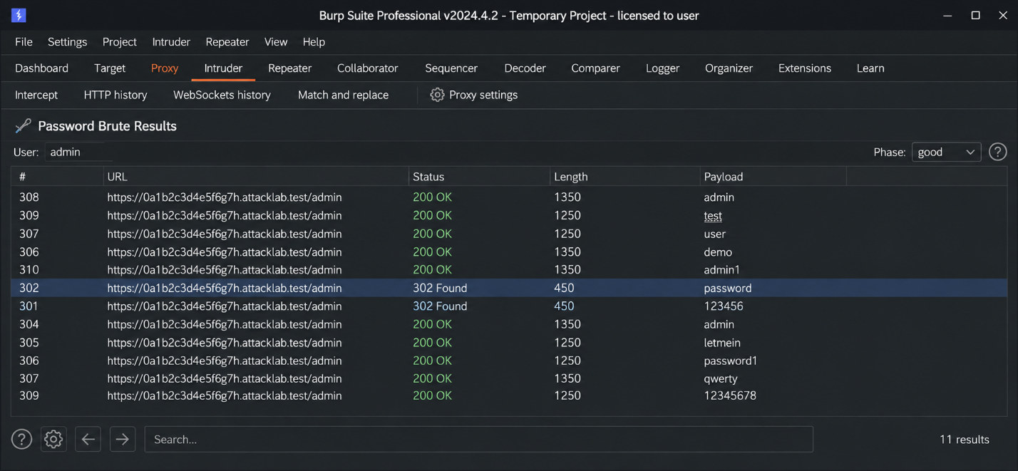
Figure 26: Successful Brute-Force Results in Burp Intruder
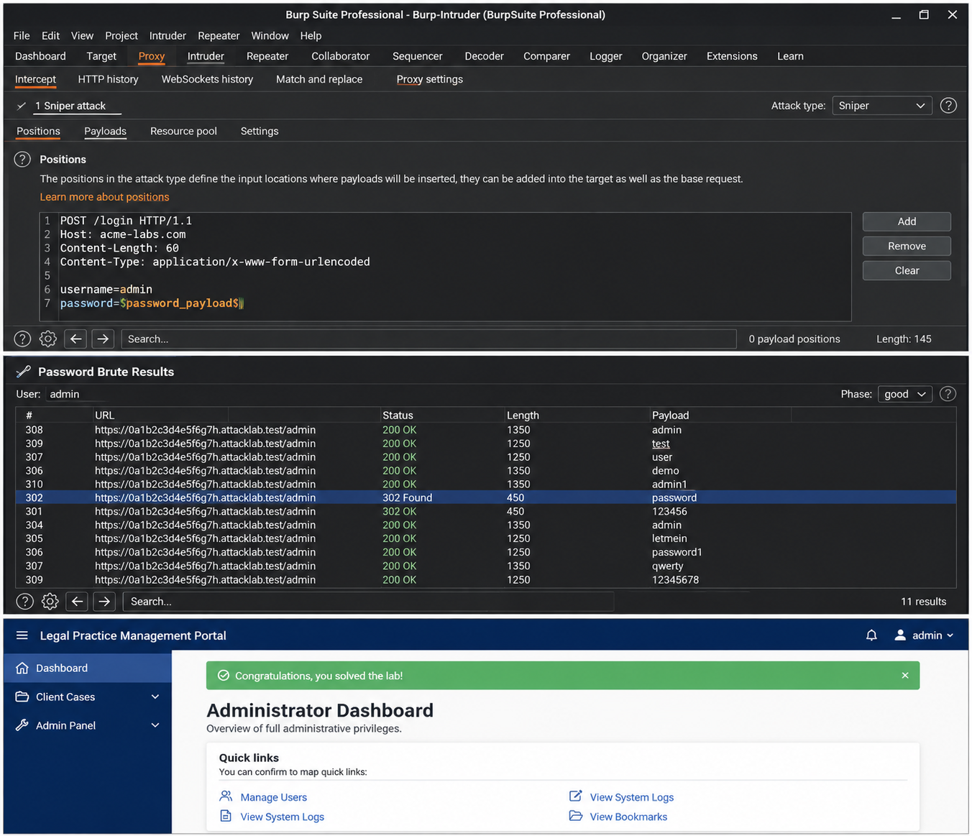
Figure 27: Accessing the Admin Panel after Successful Exploitation
I used the PortSwigger Academy lab environment and Burp Suite’s Intruder tool to assess a legal management portal. I identified a critical authentication vulnerability. By launching a brute-force attack, I successfully compromised the administrative credentials, granting full access to the application's sensitive administrator panel and dashboard.

Practical Task 3: Security Improvement Proposal
- Authentication Controls: Enforce a strict password policy (minimum 12 characters, mixing alphanumeric characters and symbols). Mandate Time-based One-Time Password (TOTP) MFA for administrative routes, and lock user profiles for 15 minutes after 5 consecutive failed login attempts.
- Input Validation Measures: Deploy a strict, centralized validation filter on the server backend. All client-supplied variables must match explicit regular expression allow-lists. Apply context-aware output encoding (such as HTML entity encoding) before displaying user input back onto any webpage.
- Logging Mechanisms: Implement structured centralized logging using JSON formatting. Log all successful and failed authentication events, access control violations, and severe runtime errors. Capture precise EAT timestamps, source IPs, and target usernames, while keeping sensitive data like plaintext passwords completely out of log files.
- Patch Management Strategy: Run automated dependency checks inside your development workflow daily. Critical security vulnerabilities must be addressed within a strict 72-hour remediation window, while general library updates follow a standard monthly release cycle.

Advanced Practical Task: Web Security Checklist
1. Authentication
Complex alphanumeric passwords enforced globally.
Strict rate-limiting or account lockout enabled on all login paths.
Multi-Factor Authentication required for administrative tiers.

2. Authorization
Access control validation checks executed explicitly server-side.
Data object references (IDOR) protected against manual parameter tampering.
Principle of least privilege enforced across all system roles.

3. Input Validation
Input data checked against regular expression white-lists before execution.
Parameterized statements (Prepared Queries) used for all database interactions.
Context-appropriate output encoding applied to block XSS threats.

4. Session Management
Session tokens generated via secure, unpredictable random number algorithms.
HttpOnly, Secure, and SameSite=Strict flags appended to cookie structures.
Session IDs rotated automatically upon successful user authentication logins.

5. Encryption
TLS 1.3 enforced across all web routes with HSTS active.
Passwords stored using modern, high-entropy hashing like Argon2id or bcrypt.
Application backup archives and database stores fully encrypted at rest.

6. Logging
All login failures, privilege elevations, and access drops logged with detailed context.
Log data forwarded automatically to an isolated, central log collector.
Plaintext passwords, API tokens, and private identification data scrubbed out before writing logs.

7. Configuration Management
All default system passwords, administrative paths, and configurations updated.
Verbose application stack trace error messages disabled on production sites.
Unused ports, development routes, and unnecessary file extensions turned off.

Challenge task
Secure Web Application Design Framework
- Security Requirements: Core baselines are set using the OWASP Application Security Verification Standard (ASVS), establishing metrics like mandatory JWT tokens for all API routes and strict schema validation for transaction values before engineering begins.
- Threat Modeling: Using the STRIDE methodology, trust boundaries are mapped out between the mobile client and the API gateway. This identifies risks like webhook spoofing on payment callbacks, which is mitigated by validating SSL certificates and verifying transaction IDs directly with the payment provider.
- Secure Coding Practices: Code structures implement defensive programming by running input data against strict regular expression allow-lists, explicitly type-casting object identifiers to prevent database injection, and suppressing detailed system error traces to avoid information disclosure.
- Testing Procedures: Security testing is fully automated within the development pipeline. Every code commit triggers automated Static Application Security Testing (SAST) and Software Composition Analysis (SCA) to block known vulnerable dependencies from ever merging into production.

- Deployment Controls: Applications are deployed using immutable container images built with multi-stage configurations. Security is maintained by running the application process under a standard, low-privileged local user account instead of system root.
- Monitoring and Incident Response: Standardized logging captures clear contextual details of authentication failures or input violations in a central security engine. If repetitive validation anomalies are flagged from a single source, automated firewall rules immediately drop and block the origin traffic.

